Reference: SNL001 / 2018

To,

M/s Brighten Education.

Dated : | 22 October 2018
Subject : | Proposal - Software for |  | SEO and Newsletters(SNL)

Dear Yvonne,

This is in reference of a proposal SEO integration and Newsletters system discussions in lieu thereof.

I am pleased to submit Annexure I (enclosed herein) --- which has the Budgets and the Standard Terms and Conditions of the proposal for the development or integrate of the said software.

I trust that you will find the same in order.

Kindly stamp and counter sign a copy of the same as a token of your acceptance to this proposal and to the terms and conditions set within as also to the referenced Annexures.

Should you require any further clarification(s) and/or information from me, please do revert?

Thank You,
With best regards,

Fangnikoue K. A.

Annexure I Proposal and Quotation

Contents
Purpose of the Project 3
Scope of Solutions 4
Salient Features 4
System Enhancement 4
Variation 5
Infrastructure required 5
Security and Data 6
Methodologies 6
Test plans and QA 6
Skills Transfer 6
Documentation and Manuals 7
Deliverables 7
Performance Warranty 7
Zero Date 7
Launch Ready Date 7
Defects Liability period 7
Time Frame 7
Standard Man-hour rate 7
Validity 8
Taxes 8
Support Policy 8
Annual Maintenance Contract (AMC) 8
Non competing clause 8
Non-Disclosure Agreement (NDA) 8
Intellectual Property Rights 9
Arbitration 9
Jurisdiction 9
Force Majeure 9

Purpose of the Project

Brighten is a devoted educational consultants at Brighten Youth Education Centre pride themselves on providing instruction and advice of the highest quality for young learners and their parents. They offer a range of services including their English learning and test preparation tutorial school, further education consultancy, the BTEC suite of vocational qualifications courses and their very own online secondhand book trading platform, Brighten Books.
Aside from a fantastic student-to-teacher ratio, their tutors have studied and worked all over the world, allowing them to focus on each child’s specific needs, helping them to fulfil every aspect of their potential.

Over the past years, Brighten has observe a decrease of students due to unknown factors.
There is very low student’s attendant to class compare to past years of their business.

Due to this decrease of business, I (Fangnikoue), perform some investigation on how to increase the number of students and help to increase the Brighten’s revenue using social media to engage customers or users.

The first step of my investigation is to check, the possibility of visitor’s access to the Brighten website and see whether the website is accessible and SEO friendly.

The below analytic show the current traffic of some of the country visiting the website including the pages most visited.

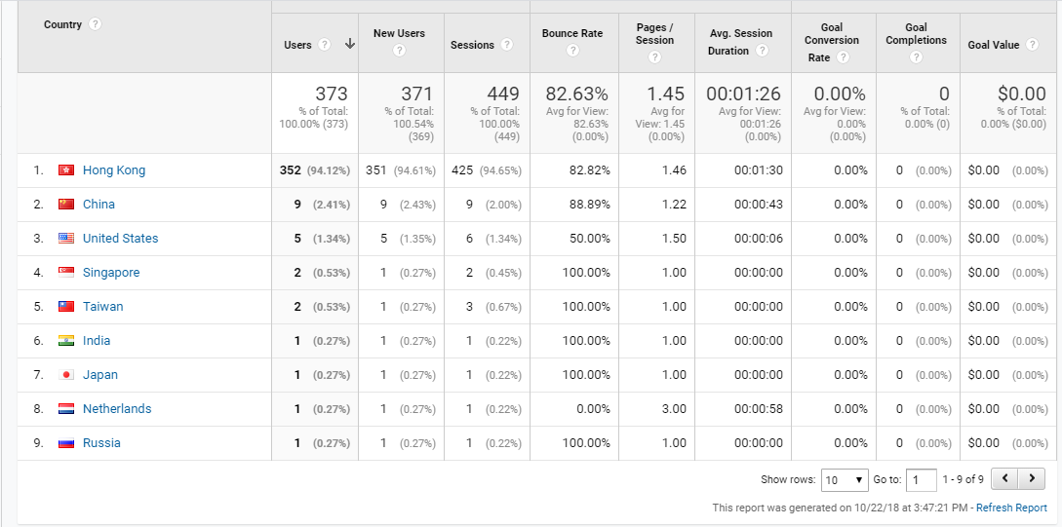

With the above analytic, it has been conclude to do more advertising using some well know social media platform such as Facebook, YouTube, Linked, and Gmail and so on and also use the current visiting page by the user ‘X’. Most of 98% of Brighten visitors visited the articles pages. So it is better to reinforce the sale force on that area by engaging those visitors to subscribe to the current visiting page for a Newsletter a new articles and email marketing about.

Scope of Solutions

The Scope of solutions would include:


Analysis &/or development of tools to improve the SEO.
Perform ads on most visited social media channel.

- Add a subscriber function on the current visiting article page.

- Development of a new system to create a Newsletters for a new article and send it to all the subscribers and Emails marketing.

Salient Features

I recommend that, you consider the development of the said software package using PHP as the code behind and with Linux Centos server as the backend. The software would be centralized and browser based; i.e. code and database will reside on the server and clients only require a browser like Opera, Safari, and Google to access the software.

The solutions are 100% web based and operating system independent. Anytime, Anyplace. Any operating system Access (AAA) is guaranteed and being web based, multi-site operations are implicit and inherent – not requiring any synchronizations or special operations / processes.

In short maintenance is a breeze. Up-dating of code is also much easier and without disruption. This is unlike a client server model, where every addition/change (new report, feature change, bug resolution etc.) would require all user machines to be updated. In this case I only need to change the code on the server. Users would not be inconvenienced and the change operations would be conducted in the background.

It is like using ERP system application. No specific IT resources are required by the client. All resources are on the web. Even data backup is automated.

The software package will be developed keeping in mind the technical aspects as well as the functional aspects. Functional aspects will be rigorously analyzed for generality and extensibility.

I will provide an extremely user friendly graphical interface. Operators conversant with the functional requirements will find it very easy to work productively on the software from day one.

The software will be dynamic in nature. Hard coding will be minimum to allow for ease of future expansions. The module(s) will be integrated and have extensive error trapping facilities. This will minimize errors due to Data Entry (human errors).

Software will be html 5 compliant and so will work on all popular browsers like Google Chrome , Internet Explorer (Microsoft), Opera, Mozilla Firefox and also Apple Safari.

System Enhancement

New feature(s) will constitute a separate scope of work and chargeable as per standard man hour rates or as otherwise agreed. Unless noted otherwise, the clauses set out in this document and related annexures would apply.

Variation

I will freeze system requirements before actual coding to ensure that unnecessary re-engineering is not required. Variation of specification(s) after due approval will constitute a separate scope of work.

Infrastructure required

I will be providing the solution on a Linux platform.

Hosting: I will provide the option to host on a dedicated servers in Hong Kong. You may however opt to host with any ISP (or even internally on your own server) of your choice. I have been using these ISP for more than 5 years now and have been pleased with their >99.5% uptime. Additional charge will be added to the actual project cost in a separate document.

Again – I am not ISP centric, and are open to hosting on any ISP of your choice. Minimum Software, Hardware specs of the server -- as under must be met.

The following 2 clauses on machine specifications, are applicable only if you opt to host with a separate ISP / on your own server.

Software: Development will be on PHP from version 5.6 to the latest as the backend programming language. Third party controls (Integration with the accounting and printing system) and my library (developed by me over the years) will be used for a rapid ramp up.

Hardware: Server will be on Intel platform. Proposed that the server be at minimum a i3 machine with 4 GB RAM and 200 GB HDD (or higher configuration) free.

Server Software: Linux Centos operating system from version 6 to the latest.

User machines (Clients) configurations are minimal as they are only using a browser. Bandwidth would decide speed. A robust LAN is assumed. Networking is not part of my scope.

Security and Data

At no point in time do I have access to any of your data. All your data is completely in your control and belongs solely to you. Backup of the same is automated, requiring no manual intervention -- on a pre-defined frequency – usually weekly and incremental daily backup. This backup is mirrored and co-located to ensure a robust Disaster Recovery plan.

Additionally, if you wish, you may at any time, without intimation to me, back up the data in standard xml / sql / excel formats without any assistance from me – on your own server, remove-able hard disk etc. All data is in a non-proprietary format and can connect to other systems / ERP etc.

Critical data will always be encrypted using standard SHA 256 encryption.

After deployment, I will not have access to your software and / or be aware of your login / passwords. Whenever assistance is required for resolution of any issue, you will be required to give me a temporary login / password.

NOTE: Statistically, most data theft (~ 90%) is internal embezzlement.

Irrespectively, to protect your data, the solutions are protected through multiple layers as enumerated herein below. This ensures that access is bona-fide and rogue elements do not access your data.

 IP lock – only computers sending in a request that are not listed in the system black list will be granted access.

Basic Login / password protection.

Digital Certificates / usb token: Optional layer --You may additionally opt to add this layer of protection wherein only users with a physical token can access the system. Alternately only machines having a digital certificate can access the system.

Mobile OTP: If you are having very sensitive data, I can deploy the concept of OTP (One time password) like banks. A one-time password is sent to the user’s mobile &/or mail (provided he/she passes the above security clearances). This password is valid for one use or for „n‟ hours (as per your input). This ensures a 2 level security of – what you know (like password) and what you have (like a mobile).

Roles – Tasks: Once access is granted, then the concept of user roles comes in. So based on the seniority (role) of the user, he/she will be granted / denied access to forms / data as per business rules.
As indicated above, critical data will be encrypted (SHA256)

Methodologies

I will follow highly modular and internationally accepted methodologies and tools. This will ensure reduced post development modifications to a large extent. Development time and cost is consequently kept within control.

Test plans and QA

Apart from Unit and Integration tests, I will also conduct Module Tests and User Interface tests to conform to usability standards.

Skills Transfer

Training would be imparted at your choosing location. Technical training would also be imparted either at the location choose by me or alongside with the user training.

Documentation and Manuals

I will provide comprehensive documentation in an electronic format. User Manual, and Help documentation. This will allow users to easily locate the various elements of the system and there will be less dependency on any individual(s).

Deliverables

The following deliverables will be made available to you in a digital format:-


SNL consisting of the following

- Project plan
- system overview and functionality
- database structure
- system source code
- brief description of each function/program
- screen formats
- report formats
- Documentation, as detailed in the said clause

Performance Warranty

I warrant my code. In the rare event of bugs being found in my code, after the Defects Liability period, I will rectify the same at no extra cost, as long as you are in AMC with me.

Zero Date

Zero date is defined as the date on which I receive the first slab of payment as defined in the Payment Terms clause.

Launch Ready Date

Launch ready date is defined as the date of successful installation at site.

Defects Liability period

Defects Liability period is defined as ninety days from the Launch ready date. If defects are found within this period, then the Defects Liability period gets extended by a further thirty days. This ensures near zero defect free handover.

Time Frame

I conform to achieving of Launch Ready Date of the above-defined Scope of Work within a time frame of approximately 30 man days after zero date. I will try my best to further compress this time frame to the maximum extent feasible. The dry run would commence on or before 20 days after Zero Date. The SNL deliverable would be at ~ 25 days from zero date.

Standard Man-hour rate

For this project, my standard man hour rate will be HK$200 per man hour (~ US$ 25.51 per man hour). This rate is fixed till 31st December 2018, subsequent to which a maximum 20% increase per annum is expected.

This man hour rate has no material bearing on the original project cost as the quote is a Lump sum figure. It is intended for estimation in case of change(s) / addition(s) in scope of work.

Kindly note:

I do not index the rates further on account of secretarial, admin or other overheads One man-week = 8 man-hours/day * 5 days = 40 man-hours

One man-month = 4 man-weeks = 160 man-hour Billing is in minimum units of 4 hours.

Validity

This quotation is valid for a period of 60 (Sixty) days.

Taxes

All taxes are included in the price quoted.

Support Policy

Support will be extended free till the Defects Liability period. This will ensure that you go live and are able to continue maintenance of your systems and add transactions without any support from me. Additional Support will be provided as per the terms and conditions of the AMC (Annual Maintenance Contract) as defined under Annual Maintenance Contract Clause.

Annual Maintenance Contract (AMC)

Annual Maintenance Contract (AMC) will come into effect after the Defects Liability Period and will be chargeable at a Lump Sum value of 5000 per annum.

AMC value is payable in advance. AMC hours may not be used for data entry or for operating system related issues or for running of your day to day business operations. AMC hours may however be used for assistance in configuration of system, training and related uses.

AMC includes unlimited support on phone and through email / remote desktop etc.

Non competing clause

I warrant that I will not be involved in any business or activity, which is inimical to the development of your project. I will not directly or implicitly deal in any manner, which will retard or negatively impact the success of your project.

Non-Disclosure Agreement (NDA)

I warrant that all information, physical or digital, provided by you in connection with the development of this project will be treated as confidential and not be accessible to any individual or body corporate outside my concern. All information will be made available to me on a strictly „need to know‟ basis.

Subsequent to the closure of the project, all your sample data will be destroyed and no copy will be kept as an archive with me.

Intellectual Property Rights

I retain all and exclusive rights to all the code developed for this project. You, the client, may not reverse engineer or decompile any of the code whatsoever. You may not commercially exploit the code in any manner whatsoever.

Arbitration

Any dispute or difference whatsoever arising out of or in any way touching or concerning the agreement between us, shall be subjected to a mutually agreed arbitrator whose decision shall be binding on the parties.

Jurisdiction

All issues will be subject to the exclusive jurisdiction of the courts of HKSAR.

Force Majeure

'Force Majeure’ clause will apply and will include (but not limited to) the following:

War or hostilities; riot or civil commotion; earthquake, flood, arson / fire or other natural disasters; strike or lock-out.

Execution and Agreement to aforesaid terms and conditions on next page.

In acceptance to the terms and conditions set forth herein above and to those contained in the Annexures referred herein above, the parties have set their signatures and seals below on this

22 October 2018

For, | For,
Fangnikoue K. Ayao |  | Yvonne Kwok.

